Muhammad Anas
25k-0899 Fast university
OOp Lab task 10

Exercises

Task1:
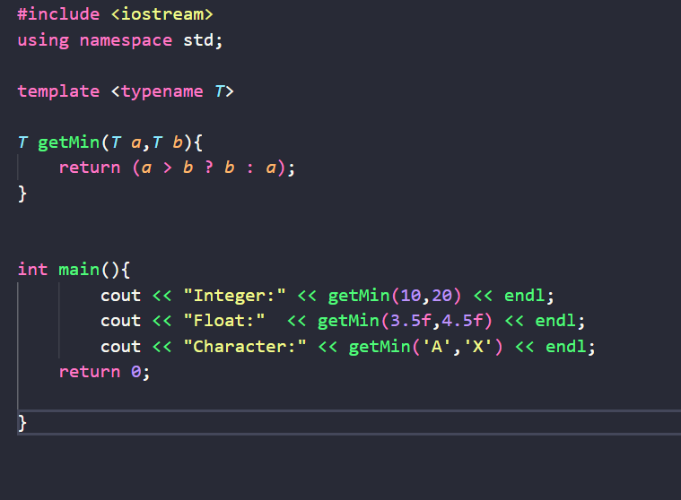

Output:
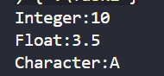

Task 2
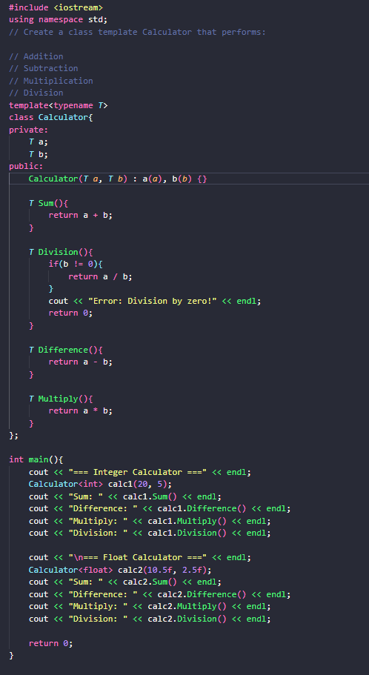

Output:
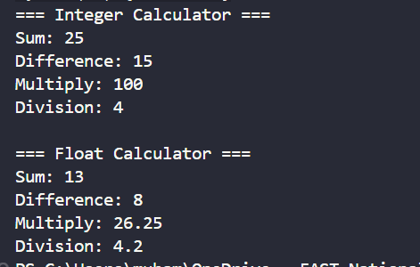

Task3:
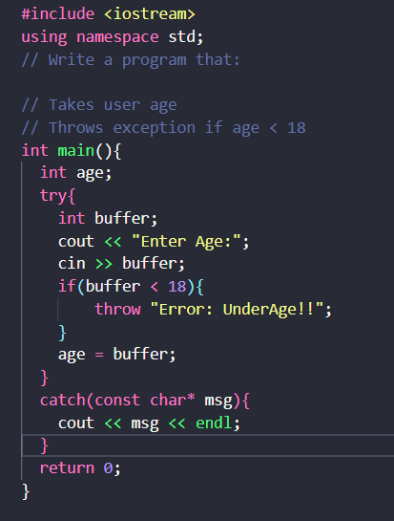

Output:
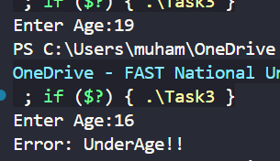

Lab Tasks

Task 1:
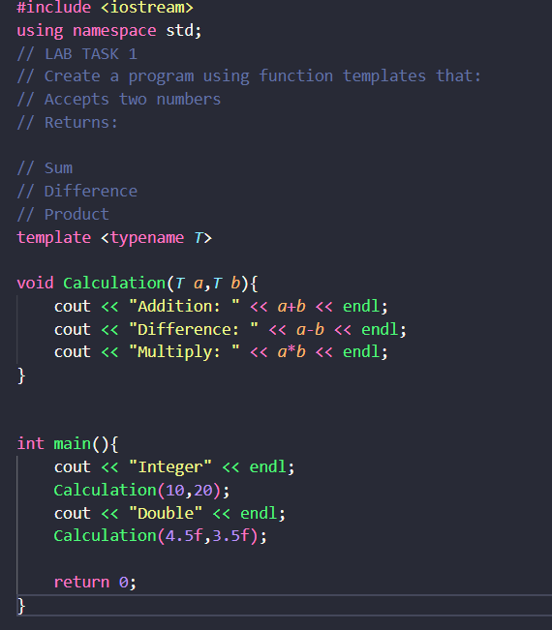

Output:
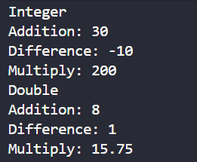

Task 2:
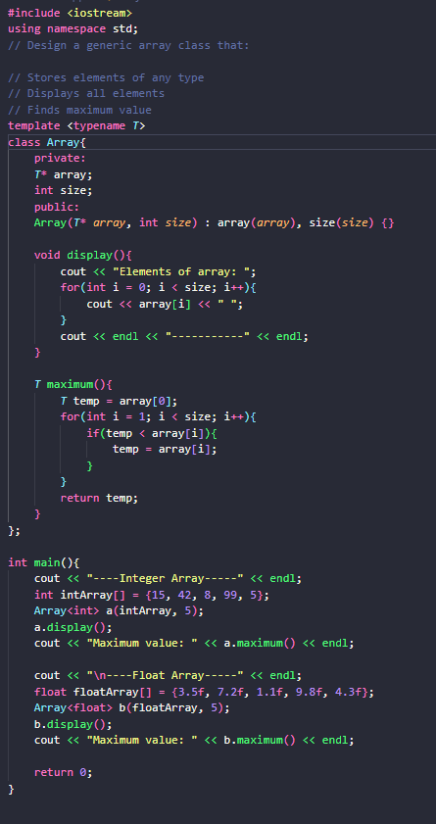

Output:
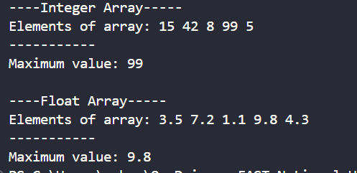

Task 3:
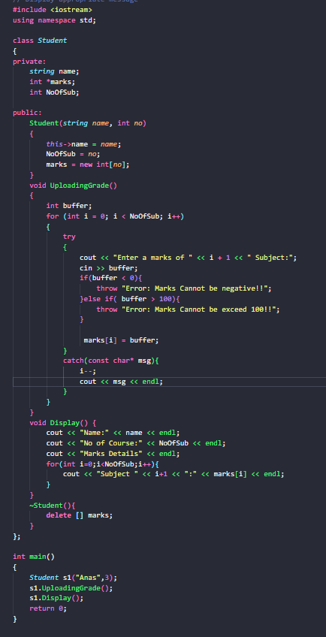

Output:
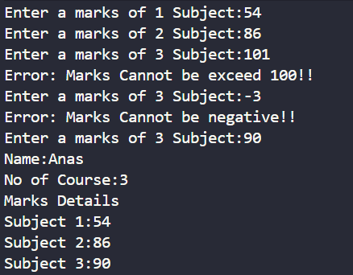

Combine task:
#include <iostream>
#include <limits>

using namespace std;

template <typename T>
class Calculator {
private:
T a;
T b;

public:
Calculator(T first, T second) : a(first), b(second) {}

T add() const {
return a + b;
}

T subtract() const {
return a - b;
}

T multiply() const {
return a * b;
}

T divide() const {
if (b == 0) {
throw "Division by zero exception.";
}
return a / b;
}
};

template <typename T>
T readNumber(const string& prompt) {
T value;
cout << prompt;
cin >> value;

if (cin.fail()) {
cin.clear();
cin.ignore(numeric_limits<streamsize>::max(), '\n');
throw "Invalid input. Please enter a numeric value.";
}

return value;
}

int main() {
try {
cout << "Generic Calculator System" << endl;
cout << "Select data type:" << endl;
cout << "1. Integer" << endl;
cout << "2. Double" << endl;
cout << "Enter your choice (1 or 2): ";

int choice;
cin >> choice;

if (cin.fail() || (choice != 1 && choice != 2)) {
throw "Invalid input. Choice must be 1 or 2.";
}

if (choice == 1) {
int x = readNumber<int>("Enter first integer: ");
int y = readNumber<int>("Enter second integer: ");

Calculator<int> calc(x, y);
cout << "Addition: " << calc.add() << endl;
cout << "Subtraction: " << calc.subtract() << endl;
cout << "Multiplication: " << calc.multiply() << endl;
cout << "Division: " << calc.divide() << endl;
} else {
double x = readNumber<double>("Enter first number: ");
double y = readNumber<double>("Enter second number: ");

Calculator<double> calc(x, y);
cout << "Addition: " << calc.add() << endl;
cout << "Subtraction: " << calc.subtract() << endl;
cout << "Multiplication: " << calc.multiply() << endl;
cout << "Division: " << calc.divide() << endl;
}
} catch (const char* msg) {
cout << "Error: " << msg << endl;
}

return 0;
}

Output:
